

Technical Design Document









Contents

|  |  |  |
| --- | --- | --- |
| Table of Contents  [1 Executive](https://n-xovwktmtjsnaxyc2mwes2xu7pohqedmdm6zjw5q-2lu-script.googleusercontent.com/userCodeAppPanel) Summary  1.1 Game Overview  1.2 Technical Summary  [2 Equipment](https://n-xovwktmtjsnaxyc2mwes2xu7pohqedmdm6zjw5q-2lu-script.googleusercontent.com/userCodeAppPanel)  2.1 Hardware  2.2 Software  [3 Evaluation](https://n-xovwktmtjsnaxyc2mwes2xu7pohqedmdm6zjw5q-2lu-script.googleusercontent.com/userCodeAppPanel)  3.1 Game Engine  3.2 Target Platform  [4 Scheduling](https://n-xovwktmtjsnaxyc2mwes2xu7pohqedmdm6zjw5q-2lu-script.googleusercontent.com/userCodeAppPanel)  4.1 Development Plan  4.2 Milestones  4.3 Updates, Maintenances & DLCs  [5 Work Environment](https://n-xovwktmtjsnaxyc2mwes2xu7pohqedmdm6zjw5q-2lu-script.googleusercontent.com/userCodeAppPanel)  5.1 Remote Collaboration  [6 File](https://n-xovwktmtjsnaxyc2mwes2xu7pohqedmdm6zjw5q-2lu-script.googleusercontent.com/userCodeAppPanel) Formats & Naming Convention  [7 Levels](https://n-xovwktmtjsnaxyc2mwes2xu7pohqedmdm6zjw5q-2lu-script.googleusercontent.com/userCodeAppPanel)  [7.1 Level](https://n-xovwktmtjsnaxyc2mwes2xu7pohqedmdm6zjw5q-2lu-script.googleusercontent.com/userCodeAppPanel) X  7.2 Asset List  8 Scripts and Complexities  8.1 Scripts - Complexities   |  | | --- | |  | | Game Development Team Members    PRODUCER  Alex Giang  Michael Yee  Shawn Chua  Tony La    PRODUCTION MANAGER  Michael Yee    PRODUCTION COORDINATOR  Alex Giang  Michael Yee  Shawn Chua  Tony La  GAME DESIGNERS  Alex Giang  Michael Yee  Shawn Chua  Tony La  SYSTEMS/IT COORDINATOR  Michael Yee  Tony La  PROGRAMMERS  Alex Giang  Michael Yee  Shawn Chua  Tony La  TECHNICAL ARTISTS  Shawn Chua  AUDIO ENGINEERS  Alex Giang  Tony La  UX TESTERS  Alex Giang  Michael Yee  Shawn Chua  Tony La |

1 Executive Summary

Game Overview

The Legend of Xela: Boid of the Wild is a 3D action adventure game inspired by various critically acclaimed games such as No Man’s Sky and Call of Duty: Ghosts. The player a gender-neutral character who appears in a mysterious and seemingly endless world with no recollection of how they got there. At the same time, evil monsters dwell within the depths of this world, aware of the player’s existence and will do what it takes to devour their being. Fortunately, the player is equipped with a pistol: a tool in which they’ll use to survive.

Technical Summary

The Legend of Xela: Boid of the Wild will be developed in at least 2 months with 4 people using the Unity game engine. If required, the game will use free assets from various resources in which credits will be given. 4 people will develop the entire code. The total production cost of the game will not exceed USD $0.00. This game will not generate any revenue and is only for educational purposes.

The game will deployed only for PC.  
The minimum requirements are still in development.

2 Equipment*

Hardware

Members of the team will utilize various computers for development, including a high-end gaming computer at the primary hardware platform for game development. Additional hardware choices include a low-end Windows PC laptop and miscellaneous hardware already owned by the team.

|  |  |  |  |  |
| --- | --- | --- | --- | --- |
| Product | Task | Cost | Quantity | Total |
| Gaming PC | Game Dev. | A lot (already paid) | 1 | A lot |

Software

All the software used for the development for The Legend of Xela: Boid of the Wild will be able to product the specified game’s purpose. The free Unity 3D program will be used for development.

3 Evaluation*

Game Engine

The game engine utilized for development for The Legend of Xela: Boid of the Wild is Unity because of its ease with creating 3D Games. It is also a great tool for education purposes regarding making games and understanding the development process behind one. Using Unity’s Engine will help speed up development rather than starting from scratch.

Target Platform

At the current time, the The Legend of Xela: Boid of the Wild will be deployed to PC. Other platforms will be considered in the future.

4 Scheduling*

Development Plans

|  |  |  |  |
| --- | --- | --- | --- |
| Product | March 2018 | April 2018 | May 2018 |
| The Game | Brainstorming and Research | Implementation of Core Mechanics | Release |

Milestones

15 March 2018, R&D Begins

10 April 2018, functioning flocking behavior implemented

15 April 2018, functioning procedurally generated world implemented

18 April 2018, raycast shooting mechanics fully implemented

3 May 2018, Game is finished!

Updates, Maintenance & DLCs

None at the moment.

5 Work Environment*

The four-man team is a multi-national and is collaborating with teammates at the SDSU Library, during class, and within their own homes. All files for the game is within their own personal computers and on the repository within Rijeka for grading purposes.

6 File Formats & Naming Convention*

|  |  |  |  |  |
| --- | --- | --- | --- | --- |
| Asset Type | Subtype | Naming Convention | File Format | Annotations |
| 3D Asset | Character | FirstPersonCharacter | .PREFAB | By Unity |
| Audio | SFX  BGM | SFXName  BGM Name | .WAV  .WAV |  |
| Scripts |  | ScriptPurpose | C# |  |
| Images |  | ImageName | .PNG |  |

7 Levels

7.1 Main Level

The only current level is a procedurally generated one, consisting of varying formations of land, nothing else. Here is an example of one. The player will wander around on this procedural land. Enemies will be spawned around and will flock with varying behaviors.

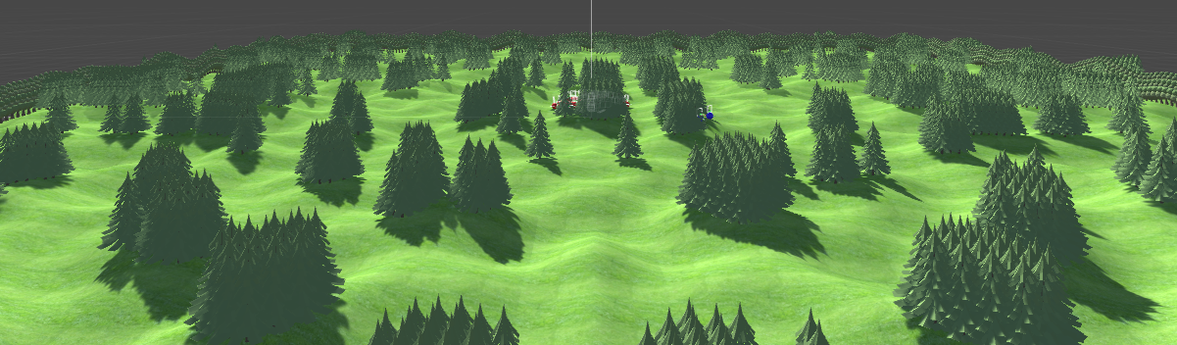

7.2 Asset List

|  |  |
| --- | --- |
| Players | Gender-Neutral – FPS Controller provided by Unity |
| Environment | Skybox |
| Audio | N/A (to be determined) |

8 Scripts and Complexities

8.1 Scripts – Complexities

|  |  |  |
| --- | --- | --- |
| Script | Conditionals | Cyclomatic Complexity |
| Flock.cs | If statements: 9  For statements: 1 | 11 |
| FlockController.cs | If statements: 49  For statements: 3  While statements: 2 | 76 |
| GenerateInfinite.cs | If statements: 6  For statements: 9 | 21 |
| GenerateTerrain.cs | For statements: 1 | 6 |
| GraphController.cs | If Statements: 1  For statements: 2 | 7 |
| GunControl.cs | If statements: 6 | 11 |
| TargetScript.cs | If statements: 1 | 3 |
| PlayerHealth.cs | If statements: 1 | 3 |
| ScoreScript.cs | If statements: 4 | 10 |
| Treepool.cs | If statements: 1  For statements: 2 | 8 |
| Wallpool.cs | If statements: 1  For statements: 2 | 8 |
| QuitOnClick.cs | If statements: 0 | 2 |

Cyclomatic Complexity based off of values provided in Microsoft Visual Studio.